Two-Sample T-Test and CI: New machine, Old machine
Method
μ₁: mean of New machine
µ₂: mean of Old machine
Difference: μ₁ - µ₂
Equal variances are assumed for this analysis.
Descriptive Statistics
Sample | N | Mean | StDev | SE Mean
New machine | 10 | 42.140 | 0.683 | 0.22
Old machine | 10 | 43.230 | 0.750 | 0.24
Estimation for Difference
Difference | Pooled  StDev | 95% Upper Bound  for Difference
-1.090 | 0.717 | -0.534
Test
Null hypothesis | H₀: μ₁ - µ₂ = 0
Alternative hypothesis | H₁: μ₁ - µ₂ < 0

T-Value | DF | P-Value
-3.40 | 18 | 0.002

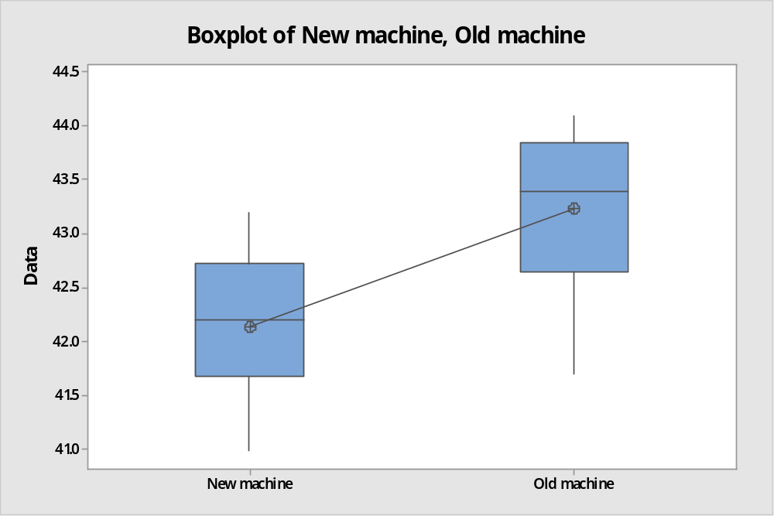

Conlcusion:
The boxplot clearly shows that the new machine has significantly lower mean that of old machine. the shape of the new machine is symmetrical while the shape of the old machine is slightly left skewed. but the variation of packing time both machine is almost same. Hence two machines are same in terms of process standard deviation but they are different in terms of average processing time.
Since p- value <<α -value =0.05, we strongly reject the null hypothesis that the average packaging time is same and hence conclude that packaging time is significant difference. Comparing average packing of new machine (42.14) and that of new machine (43.23), the new machine is packaging significantly faster than the old machine. hence new machine is superior to old machine

